A computer network is a set of devices connected through links. A node can be computer, printer, or any other device capable of sending or receiving the data. The links connecting the nodes are known as communication channels.

Advantages

* **Security:** It provides limited interaction that a user can have with the entire system. For example, a bank allows the users to access their own accounts through an ATM without allowing them to access the bank's entire database.
* **Faster problem solving:** Multiple computers can solve the problem faster than a single machine working alone.
* **Computer Network** is a group of computers connected with each other through wires, optical fibres or optical links so that various devices can interact with each other through a network.
* The aim of the computer network is the sharing of resources among various devices.
* In the case of computer network technology, there are several types of networks that vary from simple to complex level.

Components Of Computer Network:

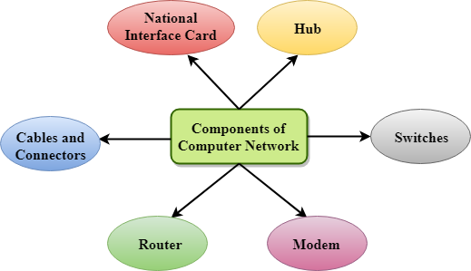

### **NIC(National interface card)**

NIC is a device that helps the computer to communicate with another device. The network interface card contains the hardware addresses, the data-link layer protocol use this address to identify the system on the network so that it transfers the data to the correct destination.

There are two types of NIC: wireless NIC and wired NIC.

## Uses Of Computer Network

### **Resource sharing, Server-Client model, Communication medium, E-commerce.**

# **Features Of Computer network**

* Communication speed
* File sharing
* Back up and Roll back is easy
* Software and Hardware sharing
* Security
* Scalability
* Reliability

# **Computer Network Architecture**

Computer Network Architecture is defined as the physical and logical design of the software, hardware, protocols, and media of the transmission of data. Simply we can say that how computers are organized and how tasks are allocated to the computer.

Peer-To-Peer network

* Peer-To-Peer network is a network in which all the computers are linked together with equal privilege and responsibilities for processing the data.
* Peer-To-Peer network has no dedicated server.

### **Advantages Of Peer-To-Peer Network:**

* It is less costly as it does not contain any dedicated server.
* If one computer stops working but, other computers will not stop working.
* It is easy to set up and maintain as each computer manages itself.

### **Disadvantages Of Peer-To-Peer Network:**

* In the case of Peer-To-Peer network, it does not contain the centralized system . Therefore, it cannot back up the data as the data is different in different locations.
* It has a security issue as the device is managed itself.

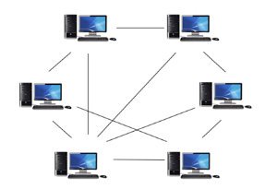

Client/Server Network

* Client/Server network is a network model designed for the end users called clients, to access the resources such as songs, video, etc. from a central computer known as Server.
* The central controller is known as a **server** while all other computers in the network are called **clients**.
* A server performs all the major operations such as security and network management.
* A server is responsible for managing all the resources such as files, directories, printer, etc.

### **Advantages Of Client/Server network:**

* A Client/Server network contains the centralized system. Therefore we can back up the data easily.
* A Client/Server network has a dedicated server that improves the overall performance of the whole system.
* Security is better in Client/Server network as a single server administers the shared resources.
* It also increases the speed of the sharing resources.

### **Disadvantages Of Client/Server network:**

* Client/Server network is expensive as it requires the server with large memory.
* A server has a Network Operating System(NOS) to provide the resources to the clients, but the cost of NOS is very high.
* It requires a dedicated network administrator to manage all the resources.

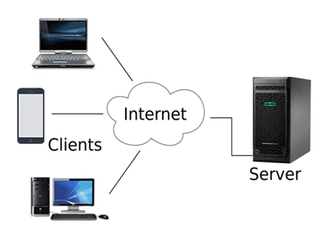

## Layered Architecture

* The main aim of the layered architecture is to divide the design into small pieces.
* Each lower layer adds its services to the higher layer to provide a full set of services to manage communications and run the applications.
* It provides modularity and clear interfaces, i.e., provides interaction between subsystems.
* any modification in a layer will not affect the other layers.
* The basic elements of layered architecture are services, protocols, and interfaces.
  + **Service:** It is a set of actions that a layer provides to the higher layer.
  + **Protocol:** It defines a set of rules that a layer uses to exchange the information with peer entity. These rules mainly concern about both the contents and order of the messages used.
  + **Interface:** It is a way through which the message is transferred from one layer to another layer.

<https://www.javatpoint.com/osi-model>

<https://www.javatpoint.com/computer-network-tcp-ip-model>

# **Transmission modes**

* The way in which data is transmitted from one device to another device is known as **transmission mode**.
* The transmission mode is also known as the communication mode.
* Each communication channel has a direction associated with it, and transmission media provide the direction. Therefore, the transmission mode is also known as a directional mode.
* The transmission mode is defined in the physical layer.

## Simplex mode

* In Simplex mode, the communication is unidirectional, i.e., the data flow in one direction.
* A device can only send the data but cannot receive it or it can receive the data but cannot send the data.

business field, radio station, Keyboard and Monitor are the examples of the simplex mode,etc

### **Advantage of Simplex mode:**

* In simplex mode, the station can utilize the entire bandwidth of the communication channel, so that more data can be transmitted at a time.

### **Disadvantage of Simplex mode:**

* Communication is unidirectional, so it has no inter-communication between devices.

## Half-Duplex mode

* In a Half-duplex channel, direction can be reversed, i.e., the station can transmit and receive the data as well.
* Messages flow in both the directions, but not at the same time.
* The entire bandwidth of the communication channel is utilized in one direction at a time.
* In half-duplex mode, it is possible to perform the error detection, and if any error occurs, then the receiver requests the sender to retransmit the data.
* A **Walkie-talkie** is an example of the Half-duplex mode

### **Disadvantage of Half-Duplex mode:**

* In half-duplex mode, when one device is sending the data, then another has to wait, this causes the delay in sending the data at the right time.

## Full-duplex mode

* In Full duplex mode, the communication is bi-directional, i.e., the data flow in both the directions.
* Both the stations can send and receive the message simultaneously.
* Full-duplex mode has two simplex channels. One channel has traffic moving in one direction, and another channel has traffic flowing in the opposite direction.
* The Full-duplex mode is the fastest mode of communication between devices.
* The most common example of the full-duplex mode is a telephone network.

### **Advantage of Full-duplex mode:**

* Both the stations can send and receive the data at the same time.

### **Disadvantage of Full-duplex mode:**

* If there is no dedicated path exists between the devices, then the capacity of the communication channel is divided into two parts.